APPLICATION HOSTING IN LINUX (apache)

AFTER LAUNCHING THE LINUX INSTANCE

STEP:1 AFTER INSTANCE CREATED,GENERATE PRIVATE KEY FOR LINUX

USING PUTTY.

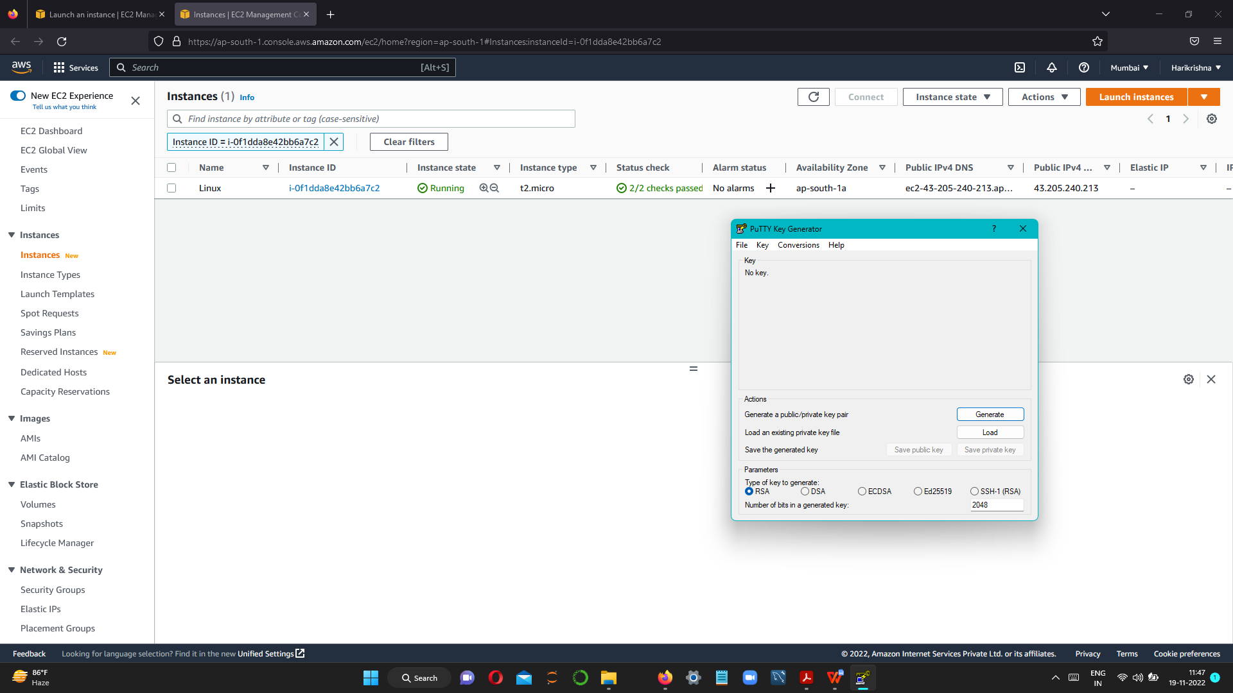

STEP 2 SAVE PRIVATE KEY FILE

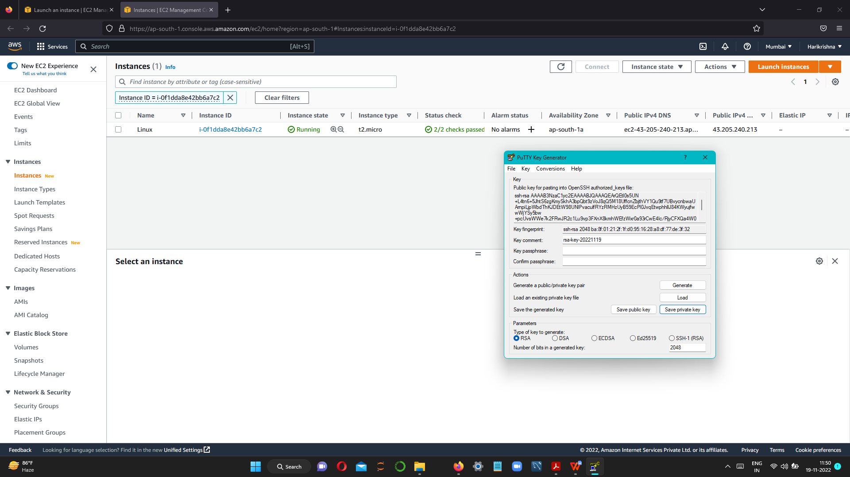

STEP 3 - COPY PUBLIC IP ADDRESS AND PASTE IN PUTTY

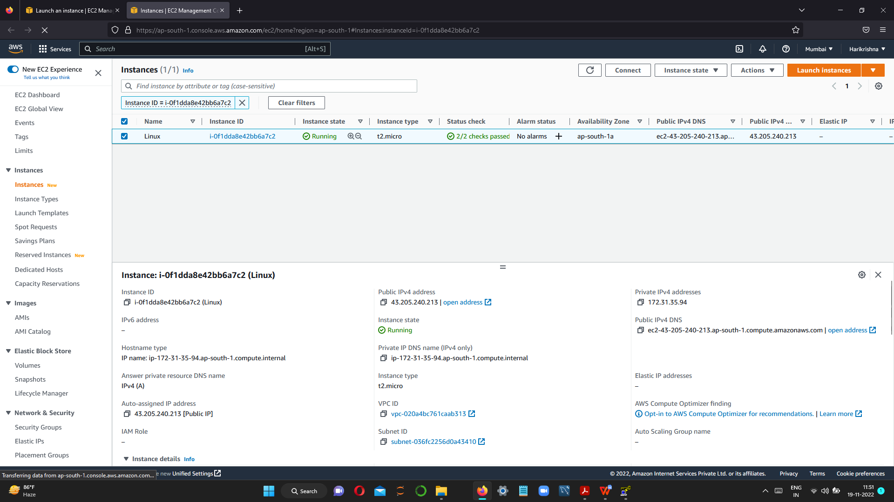

STEP 4-- PASTE IP ADDRESS IN PUTTY ,SELECT SSH--->AUTH-->BROWSE--->UPLOAD PRIVATE KEY FILE

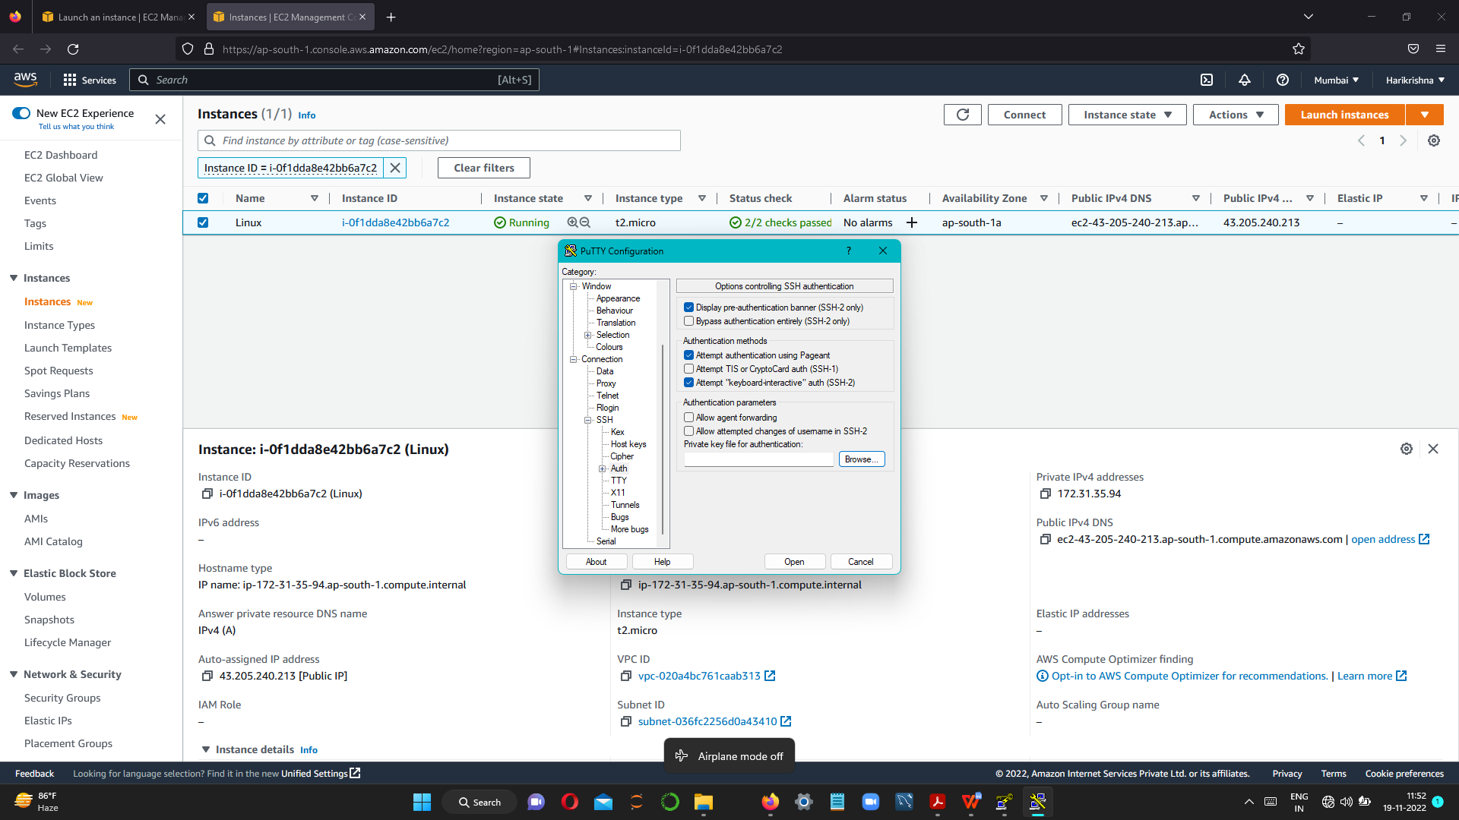

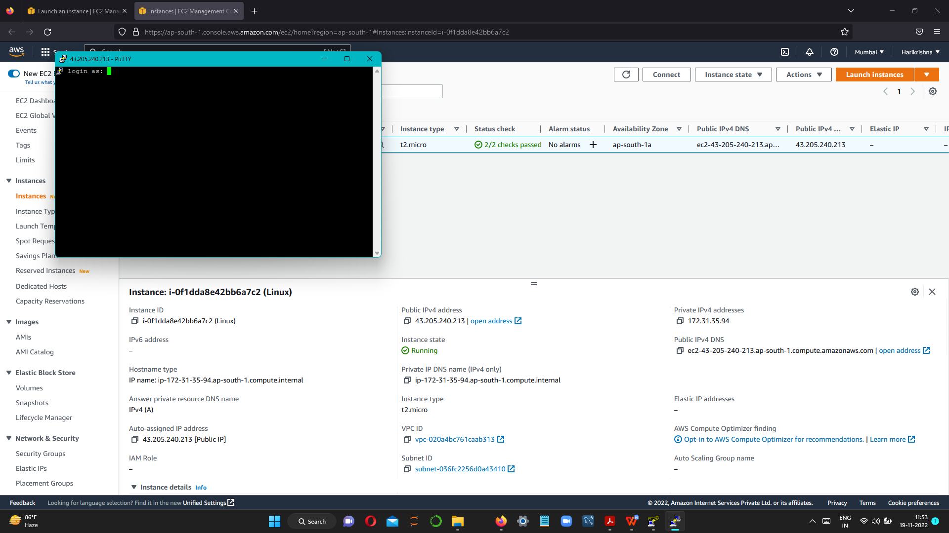

STEP 5-- TYPE EC2-USER AND PRESS ENTER



TYPE COMMAND SUDO -I FOR CHANGE TO ROOT USER



Type Yum install httpd -y for install apache server

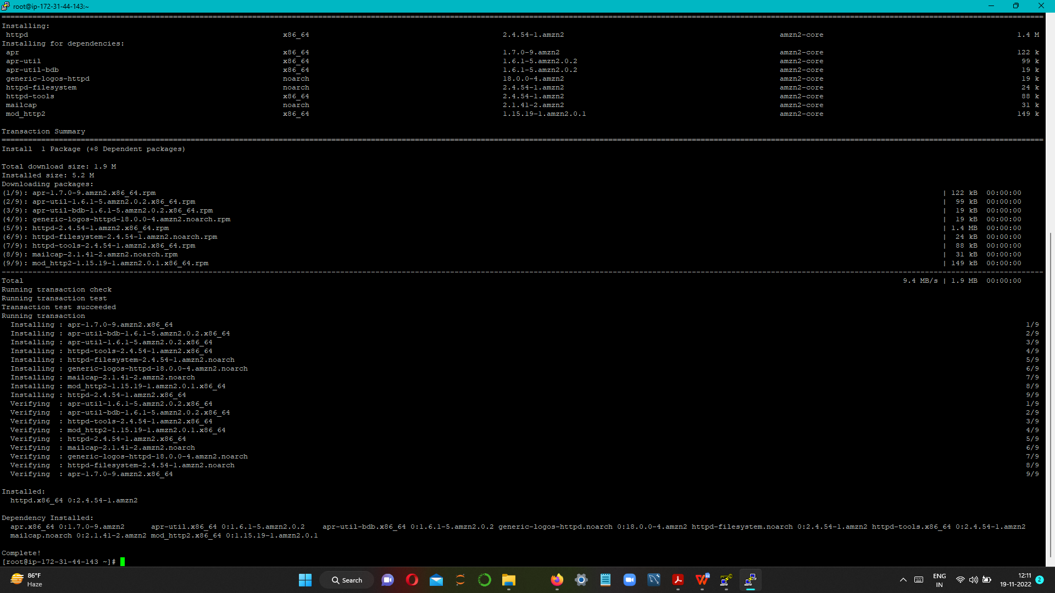

TO START SERVER TYPE THE COMMAND

SERVICE HTTPD START

TO GET PERMISSION FOR TRANSFER FILES FROM WINDOWS TO LINUX

TYPE chmod 777 /var/www/html



PASTE PUBLIC IP IN BROWSER AND CHECK SERVER IS STARTED OR NOT.



AND SERVER STARTS..

STEP-6

OPEN WINSCP TOOL AND TYPE PUBLIC IP

USERNAME:EC2-USER AND PASSWORD CLICK ADVANCED-->SSH-->LOAD PRIVATE KEY-->GETPASSWORD-->PASTE KEY IN PASSWORD

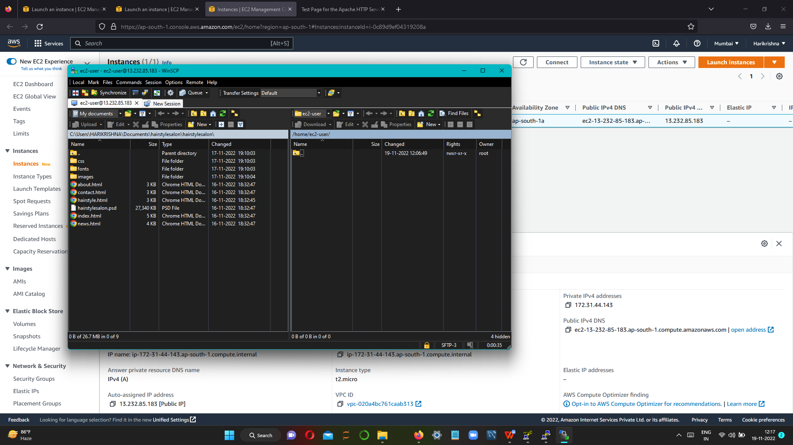

STEP 7-- AFTER OPEN THE WINSCP DOUBLE CLICK THE RIGHT SIDE FILE AND OPEN VAR-->WWW-->HTML--> PASTE THE SOURCE FILE

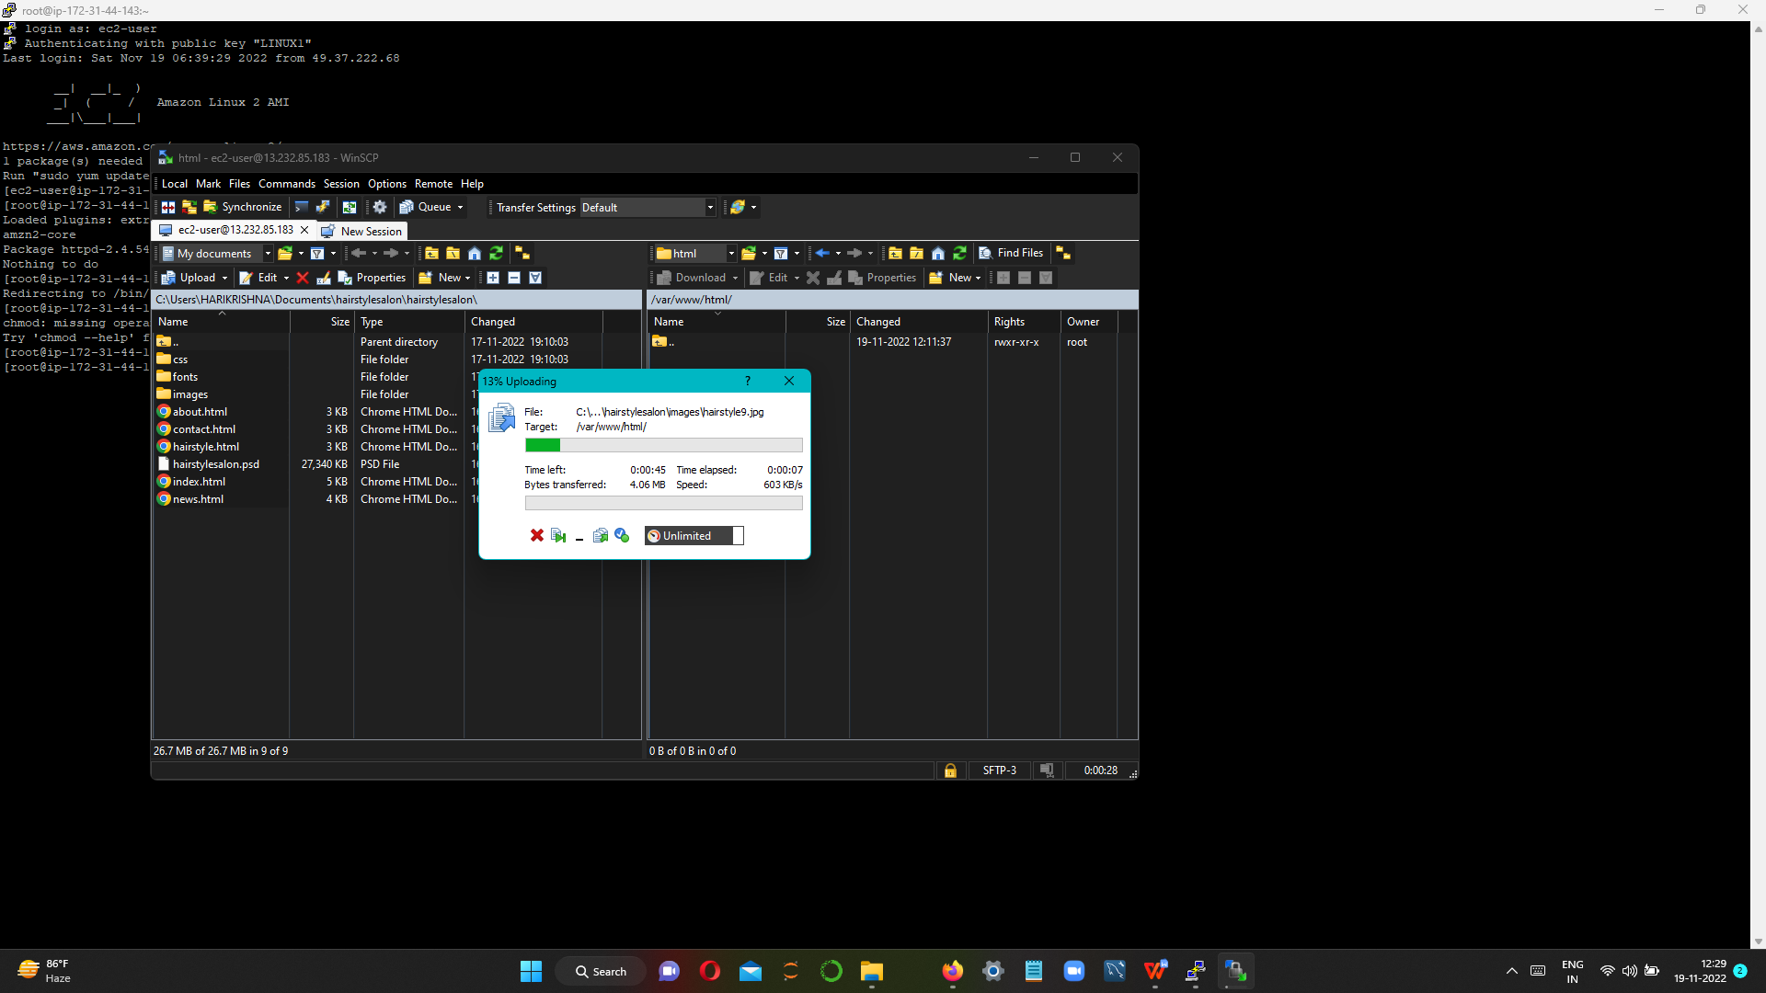

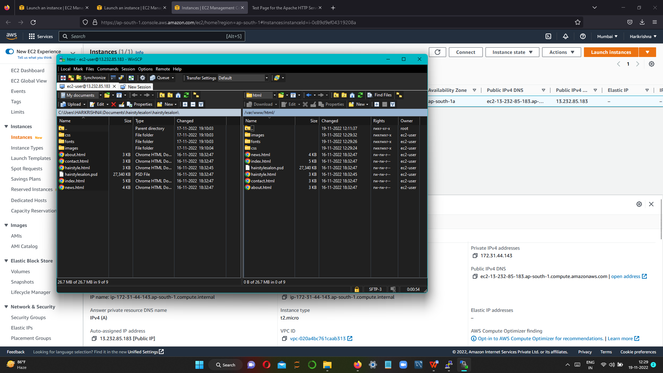

OUTPUT: HIT THE IP ADDRES IN BROWSER.

